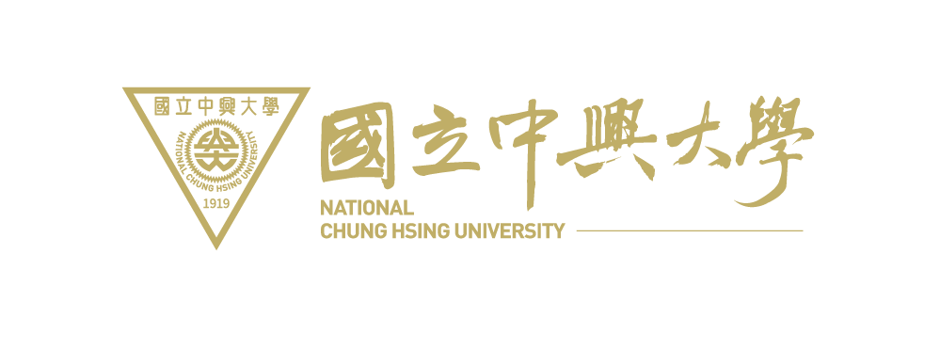

MEMORANDUM OF UNDERSTANDING
Between
National Chung Hsing UNIVERSITY, TAIWAN
and
__________________________________,___________

National Chung Hsing University, Taiwan and the _____________, hereby agree to encourage and promote academic cooperation between the two universities. The scope and procedural details of the Memorandum are as follows:

Article 1
The two universities agree to encourage and promote the following academic activities:
(a) Exchange of faculty and staff members
(b) Exchange of students
(c) Dual degree programs
(d) Joint research, lectures and symposia
(e) Other activities such as deemed appropriate by mutual consent

Article 2
Financial arrangements and stipulations concerning the exchange of students, faculty and staff members shall be specifically described in detail in separate addenda.

Article 3
Modifications and/or amendments to this Memorandum shall be only done by mutual consent.

Article 4
This Memorandum will enter into effect from the date duly signed by the Presidents of the two universities. The effective period is five years and it shall be extended automatically if neither party expresses the intention to terminate or modify this Memorandum. A written notice shall be given three months in advance of the specified date of termination, if either university wishes to terminate this Memorandum.

Article 5
Both universities shall first attempt to resolve any dispute arising out of or relating to this MOU through discussion and negotiation between the universities acting in good faith.

(signature)  Prof. Dr. Fuh-Sheng Shieu  President  National Chung Hsing University  Date:_____________________________ | (signature)  President  Date: ____________________________

