Table of Contents
Attachment 1: Research Plan 1
Attachment 2: Placement Budget Form 2
Attachment 3: Agreement of the Taiwan Sending Entity 3
Attachment 4: Letter of Agreement from the UK Hosting Entity 4
Attachment 5: Midterm report 5
Attachment 6: Final report 7
Attachment 7: Evaluation of the Placement (Taiwan Sending Entity) 10
Attachment 8: Evaluation of the Placement (UK Hosting Entity) 11

Attachment 1: Research Plan

- General Information

Sending Entity/  Department (Unit) | Mandarin:  English:
Name of Applicant | Mandarin:  English: | Job Title | Mandarin:  English:
Name of Research | Mandarin:  English:
Period of Placement* | From ________________ (Month, Day, Year) to _____________ (Month, Day, Year)
Research Sector | □ Smart Technology | □ Green Energy | □ Smart Manufacturing
 | □ Biotechnology | □ Service Innovation | □ Other, please specify _________________
Applicant Contact Information | Telephone (Office):  Telephone (Mobile):  Address:  Email:
UK Hosting Entity
*The sponsored researchers must depart Taiwan by October 15th (1st call)/ December 31st (2nd call). All placement researchers must finish their research and return to Taiwan no later than February 28th, 2025. Please refer to 3. Execution (Before departure).

- Please provide the following contents in the research plan:
- Mandarin abstract of the research plan (maximum 500 words).
- English abstract of the research plan (maximum 500 words).
- Expected influence in economic and technical aspects (maximum 150 words).
- Applicant’s Achievements: Statement of the applicant’s achievements in the past 5 years in research, work, and participation of international activities (such as research achievements, personal outstanding performance, awards, recognition records of the participation of the activities held in Taiwan or worldwide and other pertinent information to facilitate review).
- Research Information: Background, purpose, research methodology and importance of the overseas research plan.
- Entity Suitability: Suitability between the Taiwan Sending Entity and the UK Hosting Entity in the respective field of research.
- Bilateral Complementarity: Bilateral technical complementarity by the research and the contribution to the development in the respective field in Taiwan and the UK.
- Expected tasks, results, and relations with future development of the related field of the research plan.

1

Attachment 2: Placement Budget Form

Estimated Budget |  | Item | Amount (NT$)
 |  |  | Cost Borne by the Sending Entity | Cost Borne by the Administrative Office | Total Amount
 | Travel Expenses | Airfare |  |  |  | Economy Class
Relevant
Transportation Fee
 | Commercial Costs | Training Fee or Miscellaneous |  |  |  | Materials, Consultant fee etc.
 |  | Accommodation Fee*
 |  | Meals and Miscellaneous Allowance*
 |  | Insurance Fee
 |  | Other (Tax, Management Fee, etc.)
 | Subtotal
* It is recommended to follow the rules and regulations of the Directorate-General of Budget, Accounting and Statistics, Executive Yuan, Taiwan ROC.

2

Attachment 3: Agreement of the Taiwan Sending Entity

Name of Sending Entity | Mandarin:  English:
Name of Applicant | Mandarin:  English: | Employee ID number |  | Email |  | Phone number
Department |  | Unit |  | Job title
Applicant’s Highest Education | Degree (Mandarin/English):  Department/School (Mandarin/English):
Period of Placement | From______________ (Month, Day, Year) to_____________ (Month, Day, Year)
UK Hosting Entity | Name:  Address:
Collaborative Research Topic | Mandarin:  English:
Collaborative Research Duties
Short Description of the Collaborative Research
Cost Borne by the  Sending entity  (Leave blank if not applicable) | Expense incurred from overseas research:  Name of the Programme:  Code of the Programme:  Sponsoring Unit:
Head of Department/Office (Print and Signature) |  |  |  | Head of Unit (Print and Signature)

3

Attachment 4: Letter of Agreement from the UK Hosting Entity

Please include a brief description of the collaboration and the letter must be signed by the Department Head. Example:

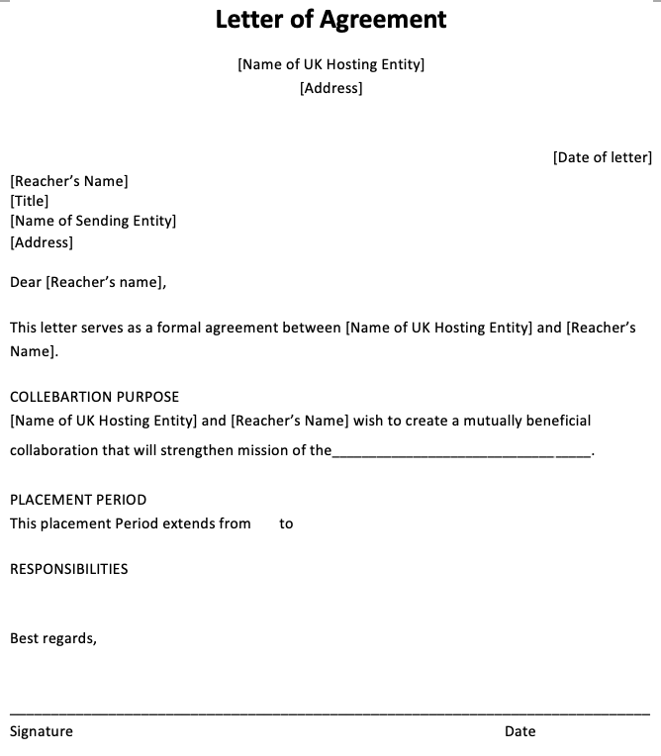

Attachment 5: Midterm report

(Both Word & PDF files are required to be summited to the Programme Office)

Contents should include:
- Report Cover
- Research Abstract
- Progress summary of the research
- Reasons for the progress difference between the expected timeline and the actual status, if any.
- Experience of conducting the placement scheme and the problems that require to be solved.

Page 1

Report Cover
Report of the UK-TW Innovative Industries Programme
(Midterm)
Name of the research:
Sending Entity:
UK Hosting Entity:
Researcher:

Execution Period: From______ (M/D/Y)
to_____________(M/D/Y)

_____Month Day, Year

Page 2

Research Abstract
  - Mandarin Abstract
  - English Abstract
  - Keywords

Attachment 6: Final report

Page 1

Report Cover
Report of the UK-TW Innovative Industries Programme
(Final)
Name of the research:
Taiwan Sending Entity:
UK Hosting Entity:
Researcher:

Execution Period: From______ (M/D/Y)
to_____________(M/D/Y)

____Month Day, Year
Page 2

Research Abstract
  - Mandarin Abstract
  - English Abstract
  - Keywords

Content of the Report
    - Please include preface, research purpose, methods, results and discussion, conclusions, and suggestions (including future direction and development), and other pertinent information.

Please explain in detail and evaluate the influence made by the placement research for Taiwan and the UK.
- The academic and application value created from the research results, and the contributions to the respective fields in the future.
- The contributions and future prospect for Taiwan and UK entities, and the possibility to expand the research in broader and deeper measures.

Please answer the following questions to evaluate your placement.
- How did your research benefit from the placement scheme?
- Is the approved research time appropriate to your research?
- Do you have any suggestions to the Programme Office with regards to the preparation time, evaluation measures, or other aspects?

Self-Evaluation Table

- Were the outcomes set in the original research plan achieved?
  - Outcomes achieved
  - Outcomes not achieved (please explain below)
    - Experiment failed
    - Experiment interrupted
    - Experiment terminated
    - Other, please specify:
2. Publishing status of the research results in academic journals or patent application:
- Journal article:
- Published, Journal ___________
- Preparing manuscript
- No action
- Other, please specify:

- Patent: □ Obtained □ Applying □ No action □ Other, please specify:

- Technology transfer: □ Completed □ In process □ No action
□ Other, please specify:

Signature of the researcher:

Date:

Attachment 7: Evaluation of the Placement (Taiwan Sending Entity)

- Were the outcomes set in the original research plan achieved?
  - Outcome achieved
  - Outcome not achieved (Please explain below)

- Please provide your suggestion/opinion regarding the “UK-TW Innovative Industries Programme.”
- How did your research benefit from this scheme?

- Do you think this placement period is appropriated for you to obtain the preliminary results?

- Do you have any suggestions for this placement scheme? Your opinions are valuable and highly appreciated by the Programme Office to improve the quality of future programmes.

Print Name and Signature of the Department Head

Date

Attachment 8: Evaluation of the Placement (UK Hosting Entity)

- Were the outcomes set in the original research plan achieved?
  - Outcome achieved
  - Outcome not achieved (Please explain below)

- Please provide your suggestion/opinion regarding the “UK-TW Innovative Industries Programme.”
- How did your research benefit from this scheme?

- Do you think this placement period is appropriated for you to obtain the preliminary results?

- Do you have any suggestions for this placement scheme? Your opinions are valuable and highly appreciated by the Programme Office to improve the quality of future programmes.

Print Name and Signature of the Department Head

Date

