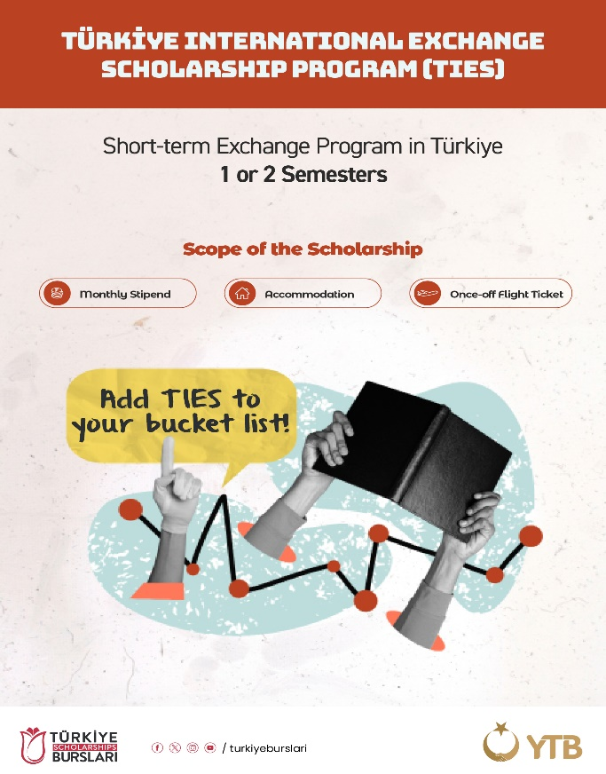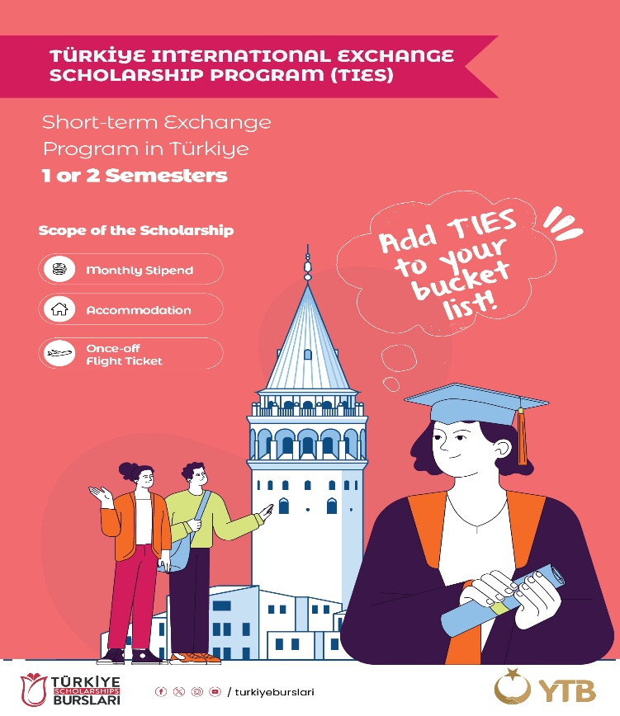
TIES (Türkiye International Exchange Scholarship Program)
In order to strengthen the social, cultural, and economic relations developed by our countries at the international level through the connections established by international exchange students, to enhance the accumulation of knowledge in higher education through international interaction, and to contribute to the internationalization of our higher education institutions with qualified international students, a new scholarship program for student exchange programs has been launched under Türkiye Scholarships.
Within this framework, the Türkiye International Exchange Scholarship Program (TIES) has been established, and our University has been selected as a pilot institution. Therefore, within the scope of the protocol signed between the Council of Higher Education, the Presidency for Turks Abroad and Related Communities, and our University, we kindly request your valuable contributions to our student exchange programs.
We extend our sincere regards and hope to continue achieving successful collaborations with our esteemed partners in the coming years.
Procedures Regarding the Application
1. Nomination:
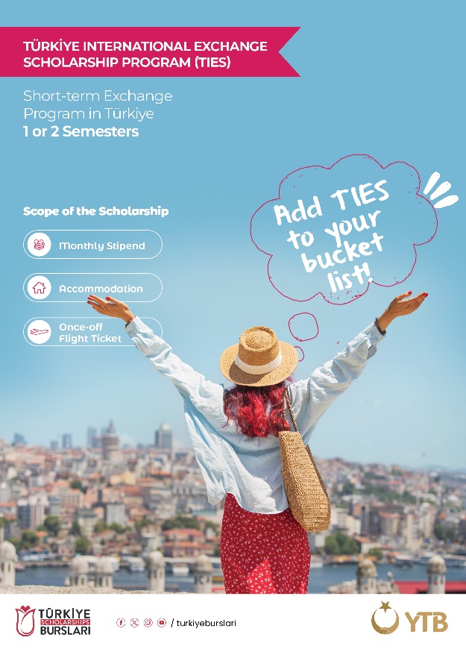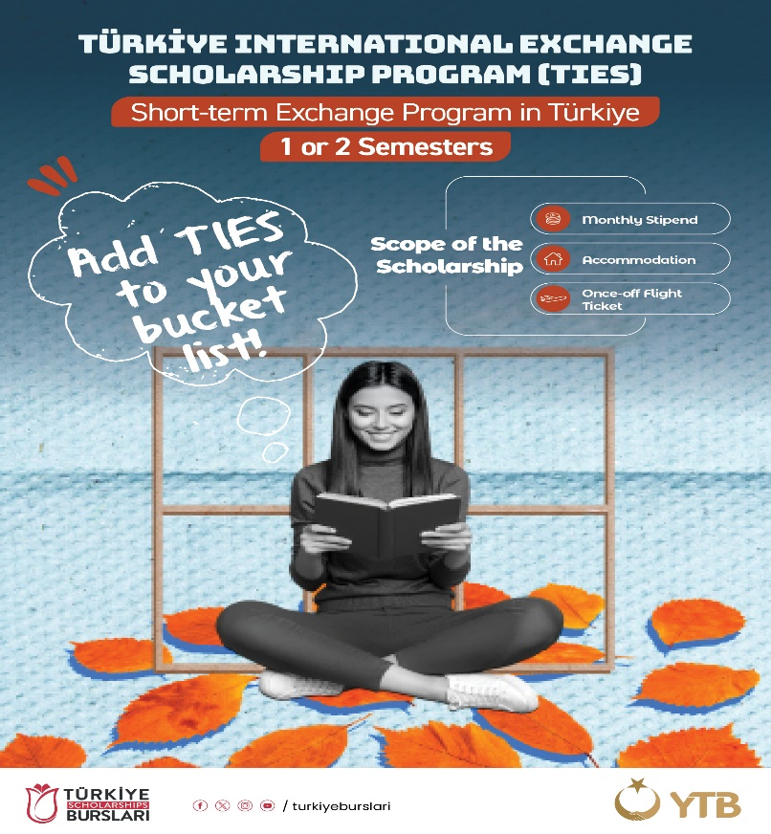
Students who wish to benefit from the TIES Exchange Programs must be nominated by their home higher education institutions via the attached form and sent to international@ohu.edu.tr If the student is accepted in coordination with our partner higher education institutions, the selected students and our esteemed partners will be duly informed.
2. Who Can Apply:
- Undergraduate students with a minimum cumulative GPA of 2.50/4.00 or 65/100 are eligible to apply.
- Graduate (Master’s) students with a minimum cumulative GPA of 3.00/4.00 or 76/100 are eligible to apply.
- Applicants must be at most 29 years old. Students older than 29 will not be provided with accommodation; therefore, please pay attention to the age requirement.
- Students who wish to stay for one semester may apply for the fall semester only. Those who wish to stay for two semesters must select both fall and spring semesters. It is not possible to apply for the spring semester only.
- The program is not open to students of Medicine and Dentistry faculties.
- Applicants must have sufficient proficiency in English or Turkish to follow courses. Students with at least a B1 level certificate in English or Turkish, or whose language proficiency is officially confirmed by their home institution, may apply. Applicants are expected to have good speaking skills in English or Turkish.
- Applicants must hold a citizenship other than that of the Republic of Türkiye. Turkish citizens, individuals holding dual citizenship where one is Turkish citizenship, or those who have lost Turkish citizenship for any reason are not eligible to apply for the TIES Program.
- The TIES Program is open to students enrolled in formal education programs at higher education institutions abroad. Students enrolled in open, external, non-formal, or distance education programs are not eligible.
- The duration of the student exchange must be at least one semester and at most two semesters. The semester calculation may vary depending on the academic system; however, the total duration of the exchange cannot exceed one academic year.
- Students enrolled in preparatory or first-year undergraduate programs, as well as graduate (Master’s) students in preparatory or scientific preparation periods, cannot benefit from this program in their first semester of main studies.
3. The Documents For the Applications
Students who are nominated must first submit the following documents to us. After being accepted by our institution, the selected students will be required to upload these documents to the system opened by YTB, together with their Letter of Acceptance.
- Application Form (attached)
- Copy of Passport
- Transcript (in English)
- Photograph in JPG or PDF format
Note: The course catalogue and Learning Agreement documents will be shared later with the selected students.
4. What Does the Scholarship Program Cover:
- The TIES Program covers a monthly scholarship provided to students, accommodation support, and one-time travel expenses for arrival in Türkiye and return to their home country.
- Students participating in the program will be exempt from tuition fees at the host institution; however, they are responsible for paying any fees required by their home university.
We kindly ask our esteemed partners to share the information and documents of the selected students with us and wish you success in your work.

Niğde Ömer Halisdemir Üniversitesi
Uluslararası İlişkiler Kurum Koordinatörlüğü
international@ohu.edu.tr
+903882252148

