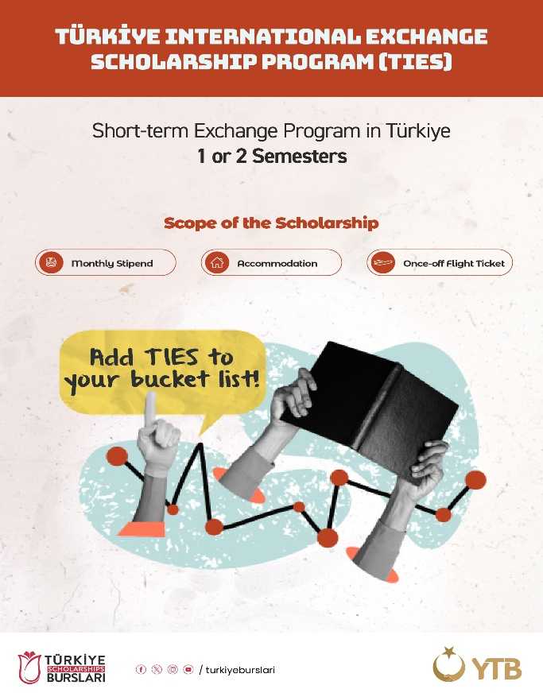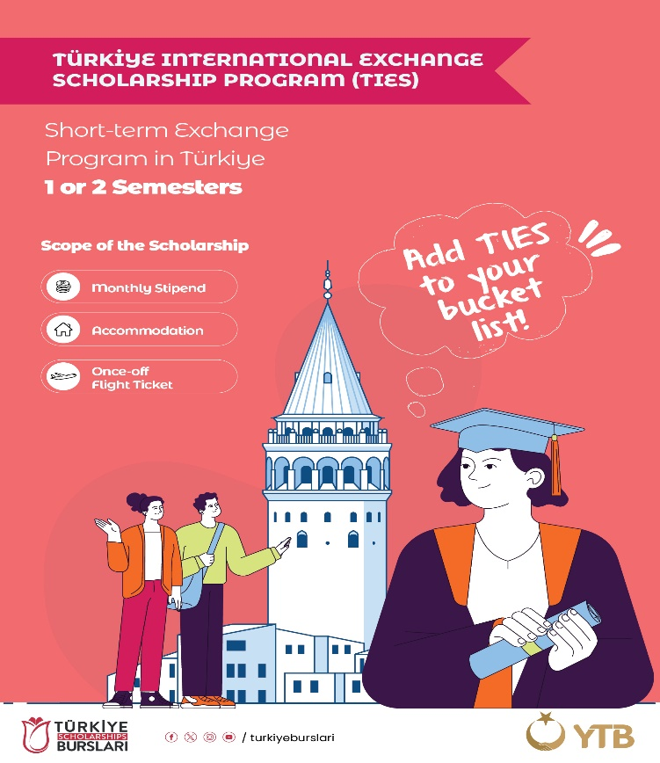

**TIES (TÜRKİYE INTERNATIONAL EXCHANGE SCHOLARSHIP PROGRAM)**

In order to strengthen the social, cultural, and economic relationships established internationally by our countries, and to increase the accumulation of knowledge in the field of higher education through the establishment of connections by international exchange students, a new scholarship program has been activated for student exchange programs within the scope of Turkiye Scholarships. Our University has been selected as the pilot implementation University for the Turkiye International Exchange Scholarship Program (TIES). Therefore, we kindly request your valuable contribution to our student exchange programs within the framework of the protocol signed between the Turkish Higher Education Council, the Presidency for Turks Abroad and Related Communities, and our University.

We extend our respects to you and hope to have good cooperation together with our prestigious partners in the following years.

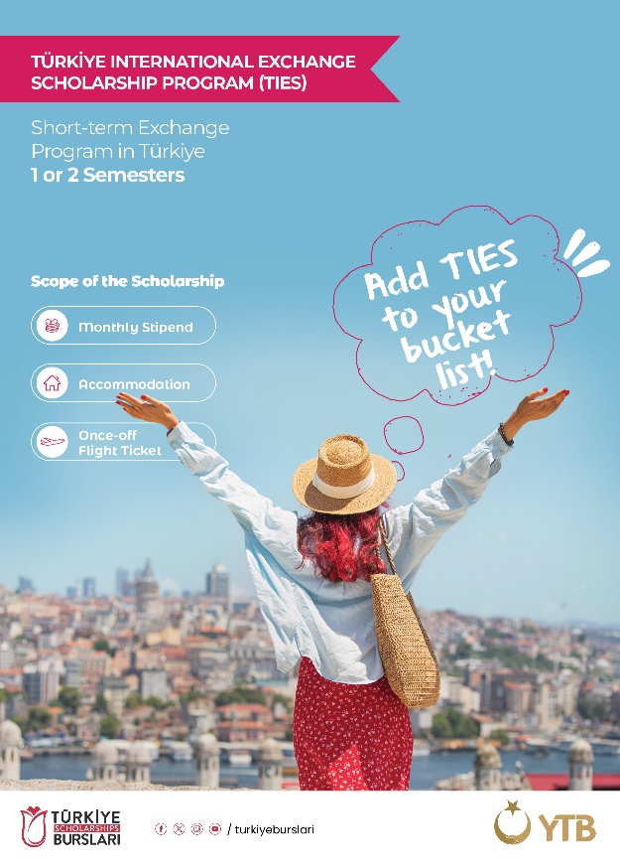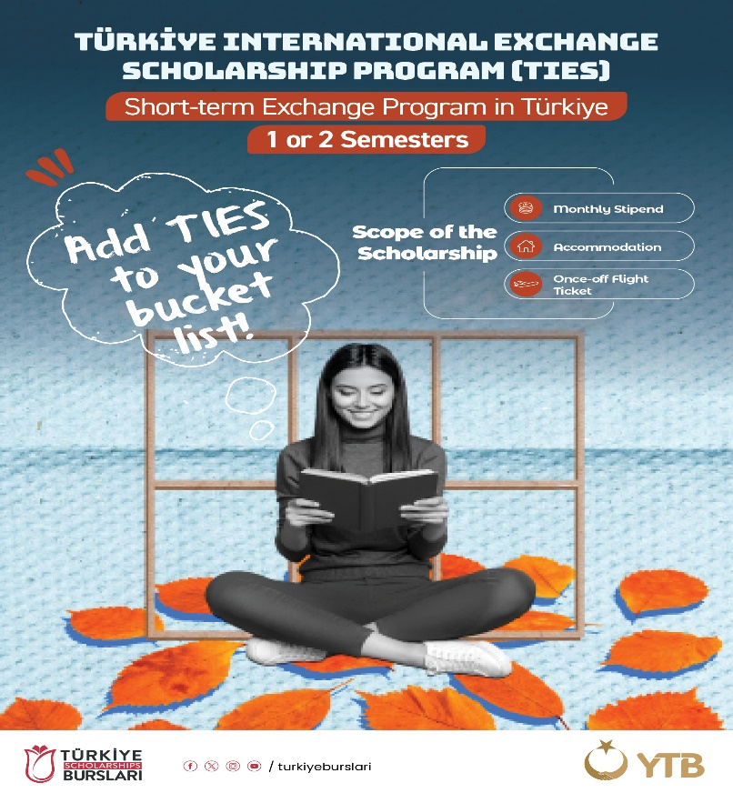

**Application Related Procedures**

1. **Nomination:**Students who wish to benefit from the exchange programs will be nominated by their own higher education institutions to the email address [international@ohu.edu.tr](mailto:international@ohu.edu.tr) using the attached form. If the students are accepted by our higher education institution, the information will be shared with the selected students and our valued partners.
2. **Who Can Apply:**

**•** Students studying at the undergraduate level with a general academic grade point average of 2.50/4.00 or 65/100 can apply.

**•** Students at the Master's or Doctoral degree (PhD) level with a general grade point average of 3.00/4.00 or 76/100 can apply.

**•** Students must have a level of English or Turkish sufficient to follow classes, with at least a B1 level of English or Turkish language certification, or approval of language proficiency by their home institution to apply.

**•** Having a citizenship other than the Republic of Turkiye citizenship. Turkish citizens or citizens with dual citizenship one of which is Turkish citizenship, or those who have lost Turkish citizenship for any reason cannot apply to the TIES Program.

• Students enrolled in formal education programs of foreign higher education institutions can participate in the TIES Program; students enrolled in non-formal, external, non-traditional, or distance education programs cannot benefit from the program.

• The student exchange period covers a minimum of one semester and a maximum of two semesters. The semester calculation can be modified considering the education system. However, the total duration of the exchange cannot exceed one academic year.

• Students in the preparatory or freshman year of associate and undergraduate programs, as well as those in the preparatory or scientific preparation periods of master's and doctoral programs, cannot benefit from this program for the first semester of their main education.

**3. Required Documents for Application:**

* Application Form (attached)
* Copy of Passport
* Transcript of Records (in English)
* A recent photograph in JPG or PDF format

***Note:*** *The course catalog and learning agreement documents will be shared later with the selected students.*

**4. What the Scholarship Program Covers:**

* Under the TIES Program, students will receive or have covered on their behalf: a monthly stipend, accommodation support, and a one-time round-trip travel allowance to and from Türkiye.
* Participating students will be exempt from tuition fees at the host university. However, if there are any fees required by their home university, students are responsible for covering those costs.

We kindly request our esteemed partner institutions to share the information and documents of the selected students with us. We wish you continued success in your work.

**Nigde Omer Halisdemir University**

**International Relations Institutional Coordination Office**

[**international@ohu.edu.tr**](mailto:international@ohu.edu.tr)

**Tel: +903882252148**